 | PRE-PROD | PROD-LIKE
Description | Member test environment for BISTECH Phase2+ | Generally version of the test system is same as production system.  However, new software changes and bug fixes (for production) will be uploaded to this test environment for a certain period of time before production release.
Available Markets | Equity Market (EQ)  Derivatives Market (DT)  Fixed Income Market (FI)  Precious Metal and Diamonds Market (PMD) | Equity Market (EQ)  Derivatives Market (DT)  Fixed Income Market (FI)  Precious Metal and Diamonds Market (PMD)
Market Rules | EQ:  Equity Market Rule Book (Turkish):  http://www.borsaistanbul.com/docs/default-source/uue/pay-piyasasi-isleyisine-iliskin-uygulama-usulu-ve-esaslari.pdf?sfvrsn=22  DT:  New functions, products and developments which will be planned to be implemented in near future will be active in the test environment with draft sessions and rules.  In addition existing contracts from production environment will also be available for test with most recent rules.  Derivative Market Rule Book (  https://www.borsaistanbul.com/docs/default-source/uue/derivatives-market-procedure.pdf?sfvrsn=18  Changes and new functionalities document in Derivatives Market Operations  http://www.borsaistanbul.com/docs/default-source/nasdaq-dokuman/changes-and-new-functionalities-document-in-derivatives-market-operations.pdf?sfvrsn=6  FI:  http://www.borsaistanbul.com/docs/default-source/nasdaqgenelmektup/bistech-faz2-gecisi-bap-degisiklikleri.pdf?sfvrsn=6  PMD:  http://www.borsaistanbul.com/docs/default-source/piyasalar/bistech-sistemine-gecis-uye-bilgilendirme-toplantisi-sunum-dosyasi.pdf?sfvrsn=4 | EQ:  Equity Market Rule Book (Turkish):  http://www.borsaistanbul.com/docs/default-source/uue/pay-piyasasi-isleyisine-iliskin-uygulama-usulu-ve-esaslari.pdf?sfvrsn=22  DT:  Apart from the extended sessions production product groups and business rules will be valid for the test environment.  However, underlying and derivative contracts prices (base, low/up limit) besides daily created option strikes based on underlying prices movements might differ from actual production system.  Derivative Market Rule Book  https://www.borsaistanbul.com/docs/default-source/uue/borsa-istanbul-as-vadeli-islem-ve-opsiyon-piyasasi-proseduru.pdf?sfvrsn=44  FI:  http://www.borsaistanbul.com/docs/default-source/nasdaqgenelmektup/bistech-faz2-gecisi-bap-degisiklikleri.pdf?sfvrsn=6  PMD:  http://www.borsaistanbul.com/docs/default-source/piyasalar/bistech-sistemine-gecis-uye-bilgilendirme-toplantisi-sunum-dosyasi.pdf?sfvrsn=4
Test Environment IP (VPN) | 10.57.3.8 | 10.57.3.22
Test Environment IP (Colocation) | 194.0.142.188 | 194.0.142.189
Connection Channels | - EQ & DT & FI Trading Workstation (TW)  - PMD Trading Workstation (GIW)  - FIX (FIX Order Entry, FIX Reference Data, FIX Drop Copy)  - OUCH/ ITCH  - PTRM  - Data Dissemination (TIP) | - EQ & DT & FI Trading Workstation (TW)  - PMD Trading Workstation (GIW)- FIX (FIX Order Entry, FIX Reference Data, FIX Drop Copy)  - OUCH/ ITCH  - PTRM  - Data Dissemination (TIP)
User Information | Available at connect.int2.uyg.borsaistanbul.com | Available at connect.int.uyg.borsaistanbul.com
User types | Brokerage Firms  Banks  HFT Firms  ISVs  Data Dissemination Vendors | Brokerage Firms  Banks  HFT Firms  ISVs  Data Dissemination Vendors
VPN | http://192.168.75.10/ueay/UEA-Site-to-Site-VPN-Altyapi-Kurulum-Kilavuzu-v1.3.pdf  http://192.168.75.10/ueay/Kullanici-Kilavuzu-UEA-FIX-Kullanicilarinin-SSLVPN-Erisimi-1-5.pdf | http://192.168.75.10/ueay/UEA-Site-to-Site-VPN-Altyapi-Kurulum-Kilavuzu-v1.3.pdf  http://192.168.75.10/ueay/Kullanici-Kilavuzu-UEA-FIX-Kullanicilarinin-SSLVPN-Erisimi-1-5.pdf
TW Version | TW_4.0.1040_80_BIST-1.63.13.9181_r139181.msi  TW documents are accessible from below menu ;  BIST Connect application Verda menu -> Application Software | TW_4.0.1040_80_BIST-1.63.13.9181_r139181.msi  TW documents are accessible from below menu ;  BIST Connect application Verda menu -> Application Software
KIT (GIW) | https://kmtptest.borsaistanbul.com | https://kittest.borsaistanbul.com
Trading Hours | Trading hours have been changed for testing purposes.  EQ:  At the end of this document  DT:  At the end of this document  FI:  At the end of this document  PMD:  At the end of this document | Trading hours have been changed for testing purposes.  EQ:  At the end of this document  DT:  At the end of this document  FI:  At the end of this document  PMD:  At the end of this document
Account Definitions | Accounts have been transferred from production for market members.  New accounts for testing are defined for ISVs. | Accounts have been transferred from production for market members.  New accounts for testing are defined for ISVs.
Collateral | All accounts are assigned a default high value. | All accounts are assigned a default high value.
End of day Reports | End of day reports are available and can be accessed via connect.int2.uyg.borsaistanbul.com manually or via http://verda.int2.uyg.borsaistanbul.com API. | End of day reports will be produced later. After the work finished, it will be accessible via connect.int.uyg.borsaistanbul.com manually or via http://verda.int.uyg.borsaistanbul.com API. For the time being, it is recommended to use pre_prod environment if end of day reports are required.
Takasbank & MKK Integration | - | -
Clearing Terminal | http://b3cw2e3/downloads/default.html | http://b3cw2e3/downloads/default.html
Technical Documents | http://www.borsaistanbul.com/en/bistechsupport/technical-documents BISTECH PROD tab | http://www.borsaistanbul.com/en/bistechsupport/technical-documents BISTECH PROD tab
Destek | bistechsupport_autoticket[at]borsaistanbul.com | bistechsupport_autoticket[at]borsaistanbul.com
Weekend status for test environments | Test environment is not open at weekends. | Test environment is not open at weekends.

CONNECTION CHANNELS:
- TW: User name, password, IP and port information is specific to member. Supplied via CONNECT.
- FIX : User name, password, IP and port information is specific to member. Supplied via CONNECT.
- OUCH : User name, password, IP and port information is specific to member. Supplied via CONNECT.
- ITCH: Equity and Derivatives Markets’ ITCH connections serve IPs listed in the table below. The ITCH data is distributed in the SoupBinTcp format as well as being specific to the test environment.
- CONNECT:
  - For Phase2+ (prod-like) test environment : connect.int.uyg.borsaistanbul.com
  - For Phase2+ (pre_prod )test environment connect.int2.uyg.borsaistanbul.com
- TIP : User name and password is same in all test environments. Users can have more than one (max 5) session with the same account in the test environments.
 |  | Phase2+ pre_prod (10.57.3.8) | Phase 2+ prod_like (10.57.3.22) | Port 1 | Port 2 | Protocol
Equity Market | ITCHMOLD | 233.113.216.61 | 233.113.216.63 | 21001 | 21002 | moldudp
 | ITCHSOUP (wan)* | 10.57.3.8 | 10.57.3.22 | 21501 | 21502 | soupbintcp
 | ITCHSOUP * | 194.0.142.188 | 194.0.142.189 | 21501 | 21502 | soupbintcp
 | ITCHRW | 194.0.142.188 | 194.0.142.189 | 24001 | 24002 | moldudp
 | GLIMPSE* | 194.0.142.188 | 194.0.142.189 | 21801 | 21802 | soupbintcp
 | GLIMPSE(wan)* | 10.57.3.8 | 10.57.3.22 | 21801 | 21802 | soupbintcp
Derivatives Market | ITCHMOLD | 233.113.216.61 | 233.113.216.63 | 21101 | 21102 | moldudp
 | ITCHSOUP (wan)* | 10.57.3.104 | 10.57.3.105 | 21501 | 21502 | soupbintcp
 | ITCHSOUP* | 194.0.142.81 | 194.0.142.80 | 21501 | 21502 | soupbintcp
 | ITCHRW | 194.0.142.81 | 194.0.142.80 | 24001 | 24002 | moldudp
 | GLIMPSE* | 194.0.142.81 | 194.0.142.80 | 21801 | 21802 | soupbintcp
 | GLIMPSE(wan)* | 10.57.3.104 | 10.57.3.105 | 21801 | 21802 | soupbintcp
All markets | TIP | 185.76.203.244  10.57.3.17 (VPN) | 185.76.203.247  10.57.3.23 (VPN) | 39101 | 39103 | soupbintcp
* User code (6 characters) and password are required for logon to ITCHSOUP and Glimpse connection.
** OUCH and ITCH tests can be performed from the colocation environment. The only exception is ITCHSOUP WAN and is opened for Wide Area Network (WAN) testing .
EQUITY MARKET TEST HOURS (PROD-LIKE & PRE-PROD)
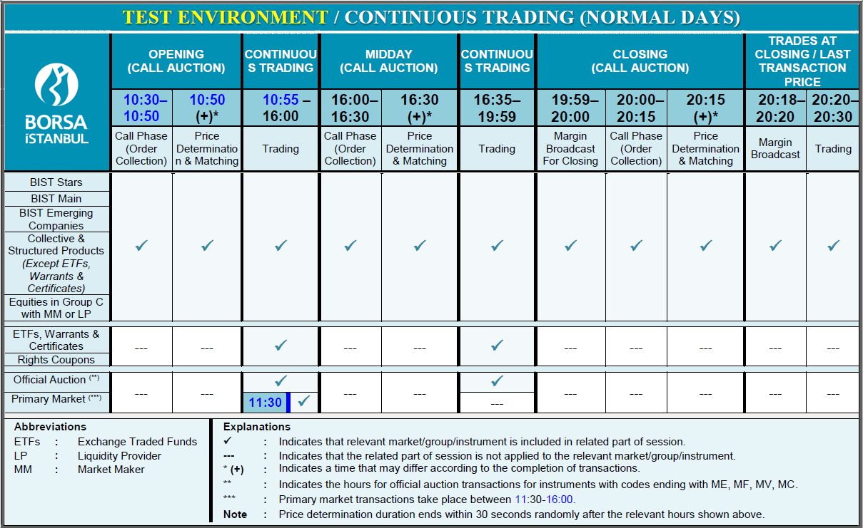
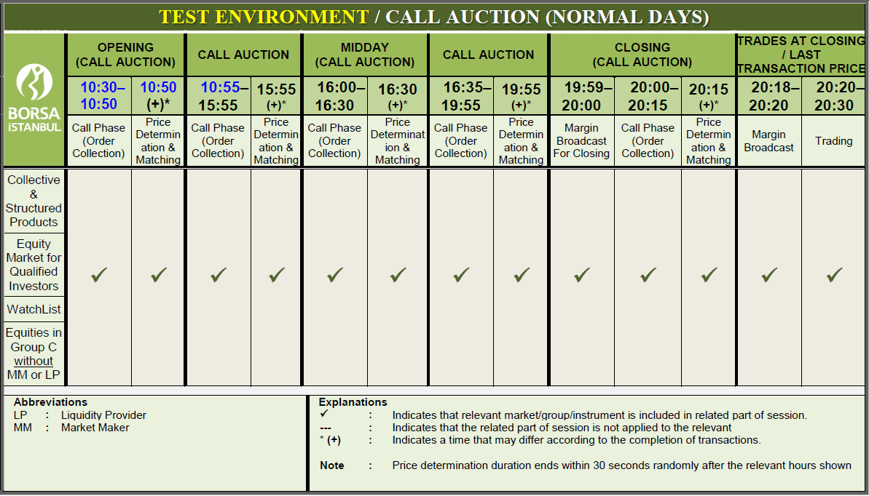

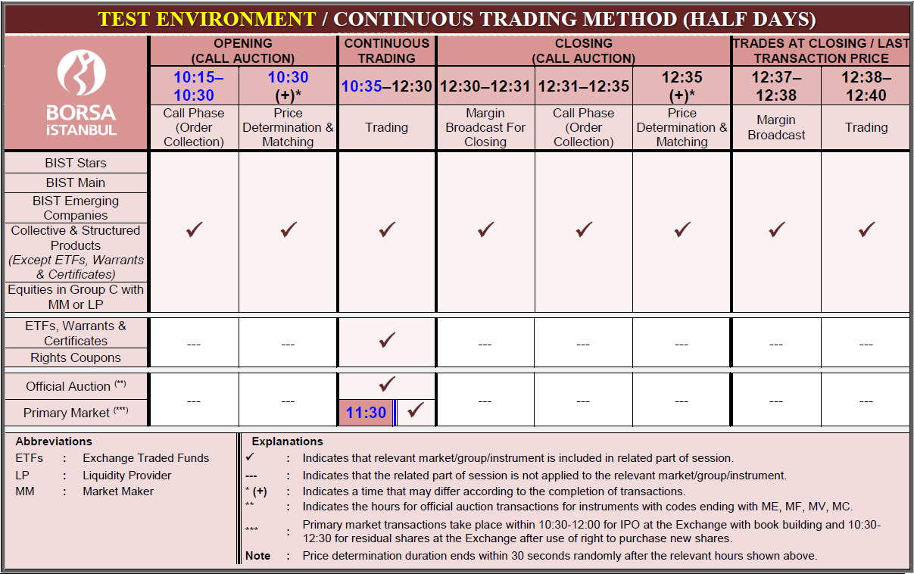
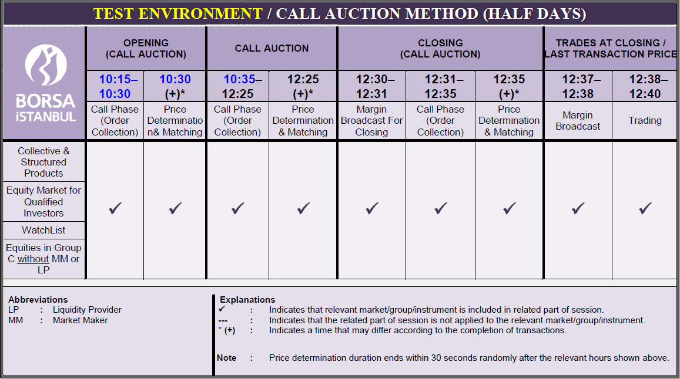

DERIVATIVES MARKET TEST HOURS
PROD-LIKE TEST ENVIRONMENT (10.57.3.22) (NORMAL DAYS)
 | Pre Normal Session | Cont.  Auction | End of Normal Session | Settle.  Price  Public. | End of Day
 | 08:30 | 08:45 | 22:45 | 22:55 | 23:00
DERIVATIVE MARKETS | ✓ | ✓ | ✓ | ✓ | ✓

PROD-LIKE TEST ENVIRONMENT (10.57.3.22) (HALF DAYS)
 | Pre Normal Session | Cont.  Auction | End of Normal Session | Settle.  Price  Public. | End of Day
 | 07:30 | 09:30 | 12:45 | 13:25 | 13:30
DERIVATIVE MARKETS | ✓ | ✓ | ✓ | ✓ | ✓

PRE-PROD TEST ENVIRONMENT (10.57.3.8) (NORMAL DAYS)
 | Pre Normal Session | Cont.  Auction | End of Normal Session | Settle.  Price  Public. | End of Day | Pre Evening Session | Evening Session Cont. Auction | End of Evening Session
 | 08:30 | 08:45 | 16:55 | 17:00 | 17:05 | 17:10 | 17:15 | 23:00
CURRENCY AND PRECIOUS METALS  DERIVATIVES MARKETS (including off-hour scheme) | ✓ | ✓ | ✓ | ✓ | ✓ | ✓ | ✓ | ✓
INDEX, EQUITY, ETF, INTEREST RATE, METAL, COMMODITY, ELECTRICITY AND FOREIGN IND  DERIVATIVES MARKETS  (excluding off-hour scheme) | ✓ | ✓ | ✓ | ✓ | ✓ | − | − | −
PRE-PROD TEST ENVIRONMENT (10.57.3.8) (HALF DAYS)
 | Pre Normal Session | Cont.  Auction | End of Normal Session | Settle.  Price  Public. | End of Day
 | 08:30 | 08:45 | 12:45 | 12:55 | 13:00
CURRENCY AND PRECIOUS METALS  FUTURES CONTRACTS (including off-hour scheme) | ✓ | ✓ | ✓ | ✓ | ✓
INDEX, EQUITY, ETF, INTEREST RATE, METAL, COMMODITY, ELECTRICITY AND FOREIGN IND  DERIVATIVES MARKETS  (excluding off-hour scheme) | ✓ | ✓ | ✓ | ✓ | ✓

FIXED INCOME MARKET TEST HOURS (Member test environment for BISTECH Phase2+)
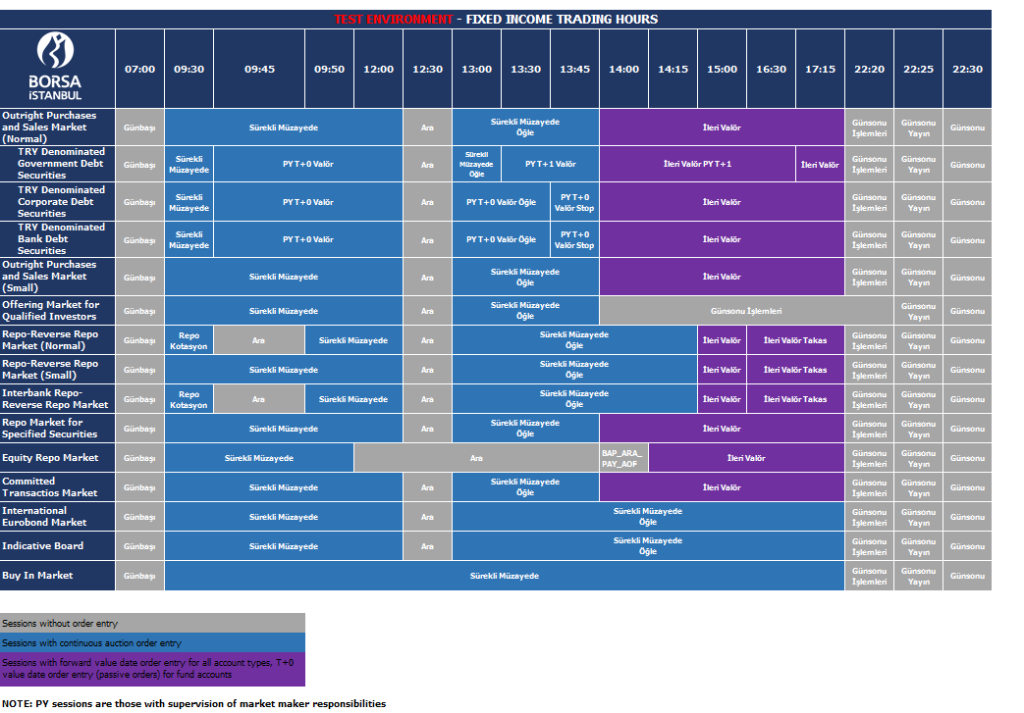

PMD MARKET TEST HOURS (Member test environment for BISTECH Phase2+)
PMD | T DAY |  |  |  |  | T+1 DAY
 | 23:45  04:00 | 04:00  14:00 | 14:00  14:15 | 14:15  16:00 | 16:00-  1610 | 16:10  23:45 | 23:45  04:00
 | Seans Kapalı | Sürekli Müzayede  (04:00-09:00 arası Erken Takas yapılamaz) | Ara | Sürekli Müzayede  (15:45-16:00 arası Erken Takas yapılamaz) | Günsonu | Sürekli Müzayede (Erken yapılamaz) | Ara

- Trades can be done only in weekdays and official holidays.
- There won’t be any trade in weekends.

